SeaGlass Carousel and Tiffany Woodland Gardens Debut at The Battery
By Nancy Lazarus on Aug. 19, 2015 - 4:07 PM
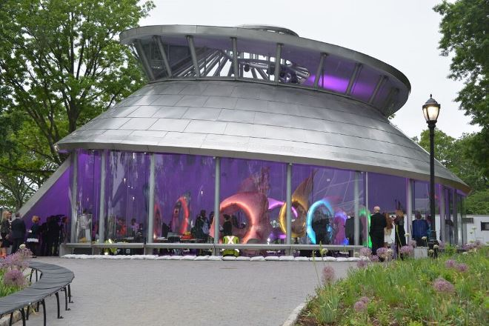
Life around the World Trade Center has literally come full circle for those who work there. First, upscale eateries and luxury shops arrived, then exclusive salons. With this week’s opening of the SeaGlass Carousel and Tiffany & Co. Foundation Woodland Gardens at The Battery, Condé Nast and soon-to-arrive Time Inc. staffers now also have stylish venues to unwind not too far from their new headquarters.
The SeaGlass Carousel, more than 10 years in the making, is a multimedia aquatic experience evoking The Battery’s maritime history as the first home of the New York Aquarium. It features 30 bioluminiscent fiberglass fish figures measuring up to 13.5 feet high and 9.5 feet wide. Visitors sit in the fish as they glide, rotate and change colors. Naturally, corporate sponsorships are available for $100,000 per fish.
FishbowlNY attended last night’s press preview and took the sea creatures for a spin. Each fish is equipped with four speakers, and we listened to remixed classical musical selections curated by SiriusXM as we learned more about the team behind the project.
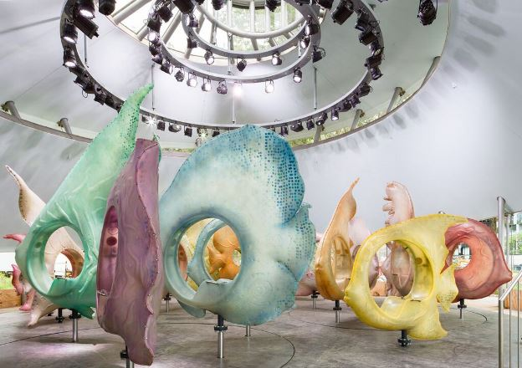
The carousel has an impressive international pedigree. George Tsypin Opera Factory, designer of The Little Mermaid on Broadway and artistic director of Sochi Olympic Games’ opening ceremony, designed the fish. Teddy Zambetti, SiriusXM’s in-house composer, worked on sound design. Industries Show Canada, an artistic team from Montreal, constructed the carousel. WXY Architecture + Urban Design conceived the SeaGlass concept and created its glass nautilus shell.
“We’re using new technology, so it’s time to move on from traditional carousels”, said George Tsypin. We utilized a turntable mechanism to create variable dancing fish movements, and underwater capsules so riders could interact with the fish. Transparent materials make the fish glow and mirror the underwater world. I’m obsessed with creating living urban spectacles.”
SeaGlass Carousel’s arrival will undoubtedly draw crowds of all ages for the colorful, hi-tech experience. Carousels were among the first social networks, initially designed for adults and then children. Since locals and overseas visitors are likely to display their tall fish tales on social platforms, (as the media did during the preview), the unique new attraction is destined to transform the tip of Manhattan into selfie central. The carousel opens to the public tomorrow.
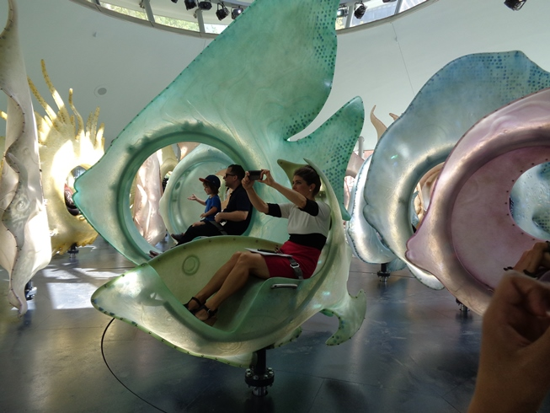
(Photos courtsey of Sara Cedar Miller, Paul Warchol and Nancy Lazarus)

